What We Know About UFOs
And Whether It Matters
By Richard M. Dolan
©2002 all rights reserved

"It takes two to speak the truth – one to speak, and another to hear."
– Henry David Thoreau
Truth and Action, Knowledge and Power
Truth in society is really a three stage process. You learn it, you tell it, you act on it. None of those steps are easy, and there are no guarantees that one stage will lead to the next.
One may know that something is true – like, for instance, the reality of UFOs – but so what? At the societal level, knowledge often fails to translate into action. Frequently, it can’t even get an official acknowledgment.
Pick a topic. Narcotics trafficking? Many detailed studies have linked narco-traffickers to the global intelligence community (including of course the American). The JFK assassination? Eighty percent of Americans, supported by a mountain of well-researched evidence, believe there was a conspiracy to kill the President. The environment? Most scientists now agree that our civilization, within a mere century, has caused a rate of species extinction that rivals some of the most vicious in our Earth’s natural history. And, oh yes, we appear to be heating ourselves into the stratosphere, too.
The result from such societal knowledge? Nothing much. Banks and spooks continue to launder drug money, official quarters explain away the public’s so-called ‘need’ to believe in an assassination conspiracy, and people continue to turn the natural world into a toxic suburban development.
Knowledge doesn’t always equal power.
Such is the case regarding UFOs. There is an overabundance of data indicating that real objects with extraordinary capabilities have been the cause of serious concern by the "national security state" for over 50 years. Many people, perhaps a majority, believe the phenomenon is real and unexplained by conventional means. Yet officially, UFOs don’t exist. They continue to be ignored publicly by the world of science.
The discrepancy between reality and official acknowledgment is great, even when compared with other areas of subterranean history. The phenomenon is real: why is no one in official (or public) quarters inquiring about it?
Asking the Wrong Questions
After all, even if one argues that the good UFO cases are the result of classified technology – which is the basic media response – we still have some important questions. Consider the triangles that are so often reported in North America and Europe. These objects are commonly described as immense and low flying, capable of motionlessness, instant acceleration in any direction, and no radius turns. And they do all this silently. No one is arguing seriously that these things are hoaxes, or misidentification of natural phenomena – both absurd in the face of an enormous body of witness testimony. So, just what does that?
The object seen in Illinois on January 5, 2000 is a good example. At least four police officers and three civilians in several nearby towns described with near uniformity a classic triangular UFO – enormous, silent, two stories high, and at low altitude, perhaps as low as 500 feet. The witnesses were credible; there was even a Polaroid snapshot.
Unable to dismiss the event, the media, predictably, blew it. Here was a golden opportunity to ask important questions, such as what kind of science can make those triangles do what they do. Instead, the media expended its energy disproving that aliens were behind it. "Probably military," is all the public learned, and that was that. Is it at least possible that there are staggering energy implications? Yes, I think so. No one bothered to ask.
But of course, we know how the media works. Just as in the world of science, gone are the days of independent investigation. Journalists are no better qualified than scientists to speak intelligently about the UFO topic, largely because there is no institutional authority granting them the permission (e.g. paying them) to investigate. It’s tough to be a lone gunman.
There have been a few sophisticated analyses of the event, such as the one done by the National Institute for Discovery Science (NIDS). Its carefully worded conclusion referred to NASA scientist Paul Hill’s monumental work on UFOs and stated that the craft’s movements "can best be explained by the application of localized, directed acceleration fields, which serve to both propel the craft and modify the airstream surrounding it in order to eliminate aerodynamic friction. Such acceleration fields are just a manifestation of spacetime metric engineering." In case you’re wondering, NIDS did not imply that this was a current, classified (e.g. terrestrial) project.
Huge triangular craft were seen in New York’s Hudson Valley almost 20 years before the Illinois sighting.
Artwork by Michael J. Kiley. Used with permission.

Within mainstream culture, however, the most accredited theory for the triangles seems to be the so-called stealth blimp. Along these lines, one writer stated blithely that "even big-time UFO buffs have to admit that it’s possible the [Illinois] mystery craft was a top-secret, man-made experiment." Others have suggested the object might be powered by microwave energy from a satellite. This would, in theory, allow for such apparent impossibilities as instant acceleration. Such technology would demand absolutely leading edge technology. Although no one even knows for sure that there even is such as thing as a stealth blimp, let us acknowledge that it’s possible.
What no one seems to be asking, however, is whether it was also possible twenty years ago, when similar objects were described many times over New York’s Hudson Valley. The stealth blimp explanation becomes more problematic the further back in time we go. We can push this line of questioning back thirty, forty, and fifty years. The triangles were less common back then, but people reported disc-shaped objects doing the same things. Did our military secretly possess this type of technology back in, say, 1950?
An objective review of the available evidence leads us to a resounding no. There is no evidence, not in the historical record, nor in any analysis of past or present technologies, to suggest a breakthrough in ‘flying saucer’ technology back in the 1950s or earlier.
Skeptics continue to argue that there is no proof that UFOs are of alien origin. This is a correct answer to the wrong question. What we do have is excellent evidence that the UFO phenomenon did not originate with our military. Let’s deal with that.
What We Know
For more than fifty years, unknown objects have violated the airspace of sensitive American installations. The capabilities of these objects have astonished our best pilots and intelligence officers. Regarding one UFO incident, a classified CIA memo from 1949 stated: "Information is desired if this was some new or experimental aircraft or for any explanation whatsoever." In 1951, the Air Force described an object that was "flat on top and bottom and appearing from front view to have round edges and slightly beveled.... Described as traveling at tremendous speed." A scientist who saw one in 1952 said it had "some propulsion system not in the physics books." An F-94 pilot who encountered one in 1952 said "the power and acceleration were beyond the capability of any known aircraft."
To a reasonable extent, we know how the American military responded to all this. There are no shortage of documents that describe the seriousness of UFOs. This 1949 FBI memo, for instance, stated:
"Army intelligence has recently said that the matter of ‘Unidentified Aircraft’ or ‘Unidentified Aerial Phenomena,’ otherwise known as ‘Flying Discs,’ ‘Flying Saucers,’ and ‘Balls of Fire,’ is considered top secret by intelligence officers of both the Army and the Air Forces.’ [emphasis added].
Gee, no kidding.
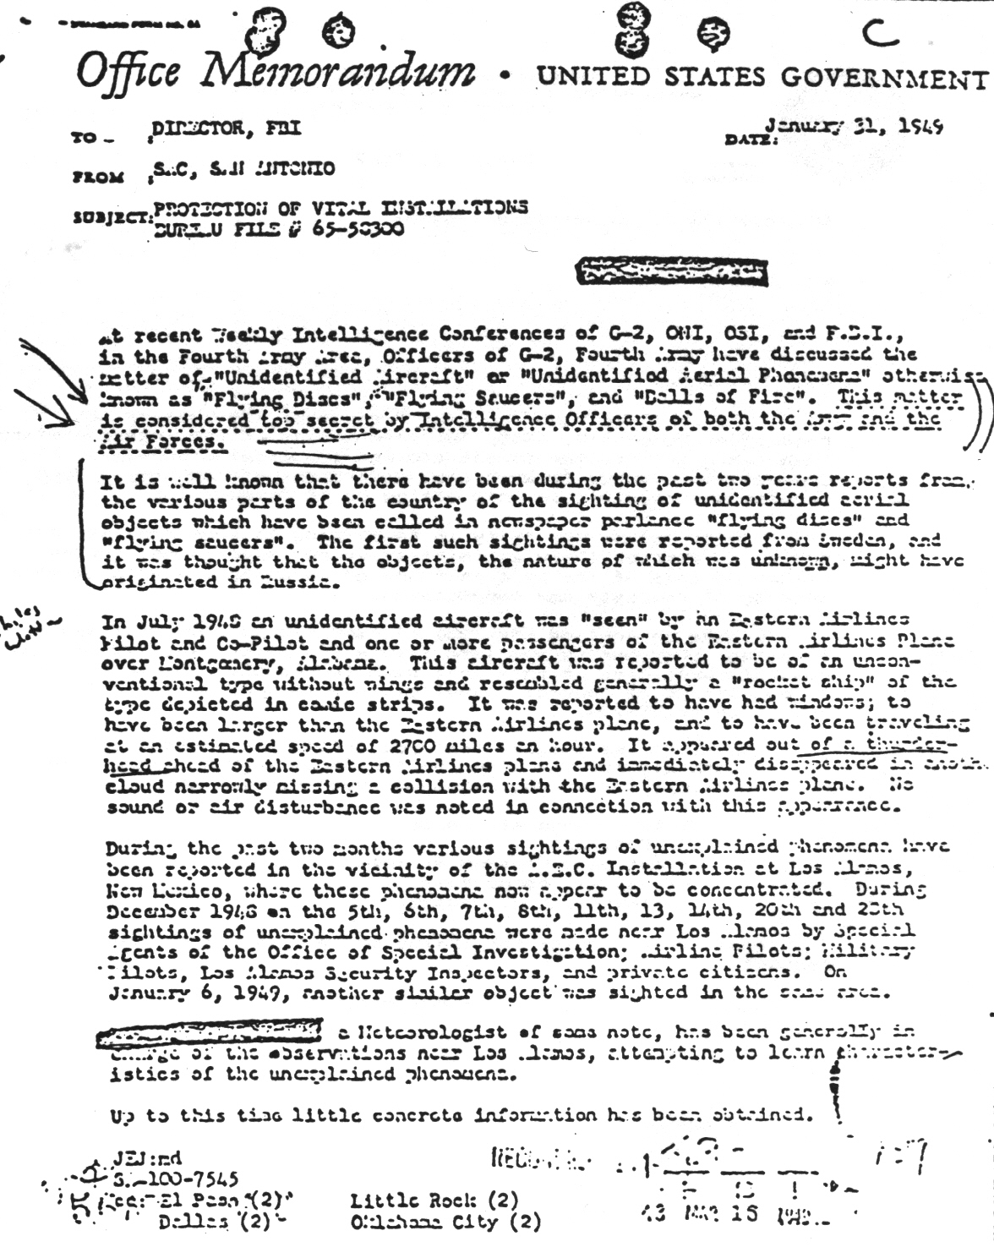
Famous 1949 FBI Memorandum stating that UFOs were Top Secret.
UFOs mattered to our military brass and intelligence officials. Americans who studied them typically believed them to be technological. As early as the 1940s, the situation became further complicated by American investigations that indicated this technology was probably neither domestic nor Soviet. Read that last sentence again, slowly.
Even after the classified Robertson Panel debunked UFOs in 1953 (largely, as I have argued elsewhere, to defuse this topic for the incoming Eisenhower administration), UFOs remained important and shrouded in secrecy. Nasty events continued to happen, such as the violation of air space at Maxwell AFB in 1954, when, according to an "Emergency Report" from that base, a "saucer like" object hovered stationary at 2,000 feet. Comparable events happened during the 1960s, 1970s, 1980s, and 1990s.
None of this tells us what UFOs are, although I suspect most people can do the math. The matter was, after all, Top Secret, and sweeping conclusions on such a topic don’t easily make it to public view, despite the Freedom of Information Act.
But we know that the extraterrestrial hypothesis was discussed (and believed) by many within the classified world. Beyond that, we can make a pretty good guess that the ETH was believed and acted upon from the 1940s onward. At the very least, I would argue that the actions taken by the U.S. national security apparatus fit better with this thesis than any other.
One might also recall the 1960 public statement of former CIA Director Roscoe Hillenkoetter: "Behind the scenes, high-ranking Air Force officers are soberly concerned about UFOs. But through official secrecy and ridicule, many citizens are led to believe the unknown flying objects are nonsense."
Strong words from a former DCI. Yet, after forty years, the academic community has yet to comment on it. Not a single scholarly book or monograph on Hillenkoetter has ever mentioned it.
What We’ve Done
Okay, so you and I can know all of these things about the phenomenon of UFOs. Assuming that we should even act on this knowledge, the question becomes, how can we act effectively? How can we, in other words, educate the public, foster open discussion, obtain official acknowledgment, receive verified factual information about the situation, and get a sense of what would then be the best thing to do?
There is scarcely any credible institutional structure within which to study this problem and, what’s more, bring the results to the wider public. The universities would be the obvious choice, but have been a circle of ignorance for over 50 years. Professors, who know nothing of the topic, will not sanction dissertation study by graduate students, who then become the next generation of ignorant professionals. Part of this stems from the paranoia of academic life; part of it is simply an issue of funding. Until money flows for the public study of this topic, you can rule out universities as a viable engine for change.
As an aside you might want to reflect on an apparent disparity. First consider that the wellspring for so much university research in this country is our military (either directly with federal money or through corporations and foundations associated with the defense industry). Then think about the importance of the UFO phenomenon to national security. If this issue were so important, one might conceivably ask, then why isn’t it being funded?
The answer is that it is not being publicly funded. We know UFOs are a classified subject. It is reasonable to assume that funding for research into UFOs would also be a classified matter.
Essentially, mainstream culture offers little in the way of enabling people to organize and study this problem. Beyond the mainstream lies the fringe, although not all fringes are created equal. Let’s look at the larger UFO organizations, such as MUFON, CUFOS, and the rest. This is something I will describe at greater length in the second volume of UFOs and the National Security State. For now I will express my feeling that these organizations – successors, in a way to NICAP and APRO – have not matched either of the older organizations in moving this topic forward and presenting it clearly to the public. In practice, they act more as vacuum cleaners: a great deal of data goes in, but very little trickles out, except in journals that no one reads. The journals of CUFOS and MUFON are not even in most libraries; none in my state of New York. Nor have these larger organizations engaged in any extended efforts to end UFO secrecy.
It is fair to look upon the two above-named groups (and a few related organizations) as encompassing most of what we might call professional ufology, academic ufology, or simply the Old Guard. Perceptive readers will know who the main players are. Over the years, they have stopped at the first rung of Truth’s Ladder; that is, knowing the facts, but not seeking to persuade or effect change. They are academic in their approach to the problem, with prose to match, unable or unwilling to draw inferences from their data, conducting specialized research, and publishing monographs for the small community of UFO researchers. Conclusions about the nature of UFOs? You’ll be hard pressed to find them. Ideas on the cover-up of information? Ditto. Even when the research is excellent, such as in the aforementioned work by NIDS, the conclusions are hardly evident, except to the most dedicated and patient of readers. It’s taken professional ufology a long time to get nowhere.
Still looking to effect change, we now move to the fringe of the fringe. Dr. Steven Greer, for instance. I am fascinated by how the Old Guard of ufology uniformly has savaged him. It would be blindness itself not to see faults with Greer and his approach. Anyone who wants to save the world is going to irritate people, and by all accounts Greer has an ego to match, as well as a history of alienating the people close to him. But consider the press conference Greer organized in the spring of 2001: this was a major event given before a packed house at the National Press Club. The speakers Greer brought in to discuss UFO secrecy were impressive and credible, and the event was more proactive than anything undertaken by Greer’s detractors.
Media coverage, however, was abysmal. Nearly a year later, nothing really has come from the event. I am even told there is no trace of it in the Press Club archives, though I have not confirmed this for myself. Thus, despite his real and alleged faults, Greer’s biggest problem is the national security state itself. It will always be true that, when it comes to winning and losing, money and resources matter more than personalities.
There are other venues for getting the truth out. The people at UFO Magazine do as good a job as anyone at trying to raise awareness of this issue and to educate the public, but the sum total of such efforts cannot match the magnitude of what we are dealing with. What we have is an utterly fragmented movement, where "the centre cannot hold."
Does Knowledge Matter?
More than fifty years have passed, and we are no closer to ending UFO secrecy. In fact, we are probably farther away than we were during the summer crisis of 1952, or the peak of UFO activity in the mid-1960s. This, despite the fact that we know much more than researchers of prior generations. After all, we have a wealth of material released by the Freedom of Information Act, something unavailable before the mid-1970s.
What has changed, however, is public awareness of UFOs. Although it is still impossible for most public figures to express their belief in UFOs, it is clear that many people do. Although I’m not really old enough to discern this from personal experience (still on the shy side of 40), it seems clear to me that among younger people in particular there is a receptiveness to the reality of UFO/ET phenomena in our world. Attribute it to the X-Files, if you like, but there has been a slow and steady shift at the foundations of our culture.
Does the success of shows like The X-Files reflect a fundamental cultural shift?
A century and a half ago, Karl Marx made the then-radical argument that a society’s political system reflects and rests upon economic power and relationships. As the economic foundation evolves, at some point the cumulative changes will be so great as to cause irreconcilable problems with the political "superstructure," forcing changes in the political system.
If we despair of the quick fix of ending UFO secrecy today, we might want to remember that insight. The foundations of our culture have gone through tremendous change since the days of the early cold war, and this includes perceptions about UFOs. At some point in the future, the dissonance between culture and power will be too great, and the political structure will have to give. For this reason, knowledge about the reality of UFOs does matter.
Given enough time, the change in official policy will eventually occur. The problem is that we do not live in normal times. Given the rapid growth in human population, the proliferation of dangerous weaponry, coupled with the alarming stress and depletion of natural resources like water, arable land, and (soon) petroleum, nothing is assured, not even the survival of our global infrastructure.
But all we can do is our best. If we can make it over our current tightrope, our knowledge of the ET presence will indeed translate one day into official acknowledgment. Mass culture will continue to change, and will eventually force the issue. The how or when, of course, is anybody’s guess.
Looming behind the preceding discussion are the most difficult of all questions: the nature of the UFO phenomenon and alien presence itself, what the alien intentions might be, and what all this means for our civilization. In my book, and in the articles I’ve written for this magazine, I have studiously avoided dealing with those questions in any detail. In my opinion, that domain is filled with too many so-called experts who do little more than blow their own version of hot air. Instead, I’ve tried to stay close to the verifiable facts.
But if you know the facts, at some point it becomes a responsibility to make as much sense out of them as you can. This doesn’t mean engaging in wild speculation, but it does mean being willing to speculate reasonably on the basis of known facts. That will be the subject of my next article.

