Timeline Dynamics
montalk.net :: (CC) 13 April 06
The rules of time travel are rooted in quantum physics. Understanding these rules reveals much about the behavior of hyperdimensional beings and the reason for certain metaphysical laws. Timeline dynamics is essentially about temporal feedback loops between the present and its available range of probable futures. This is just realm dynamics reinterpreted from the perspective of linear time, which affords additional insights as you will see. Although timeline dynamics sounds abstract, it has concrete applications pertaining to manifesting positive synchronicities, deflecting hyperdimensional manipulation, bending probability, and transcending matrix limitations.
The Nature of Linear Time
A good place to start would be to recap the nature of time. Linear time is the constant flow of variable futures into a single immutable past. Every moment of choice involves multiple optional pathways into the future. Each path is a deterministic chain of effects cascading forward like dominoes toward the next moment of choice whereupon another branching takes place.
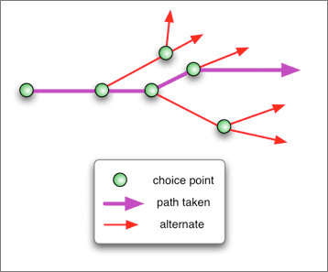
Viewed from a higher dimension, this looks like an intricate roadmap where intersections and exits represent choice points and the roads represent the causal consequence of those choices. The entire roadmap exists at once, a simultaneous whole.
Linear time is the product of our minds moving through the map, tracing out a route which becomes our remembered past. From our perspective, the route is drawn in permanent marker – once drawn, it cannot be erased.
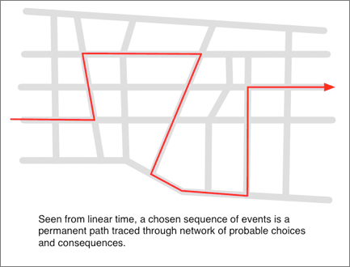
Not so for beings who have transcended linear time by becoming hyperdimensional. From their perspective, our pathway through the network is comparable to a winding string pinned to the map with thumb tacks.
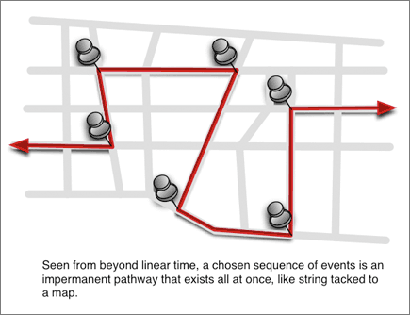
The string represents the causal progression of events, and the tacks represent our moments of choice. Multiple interacting individuals weave a complicated web whose nodes are pinned in place by the combined strength of their freewill.
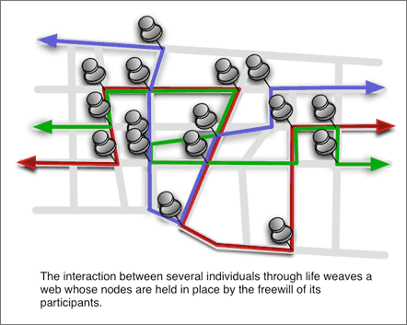
An entity outside linear time can change the past either by overriding a choice already made, or by inserting a new sequence of events where freewill was absent and thus not violable. The string network may be altered by repositioning a tack or creating a deviation in some loose section of string. Obviously the latter is easier.
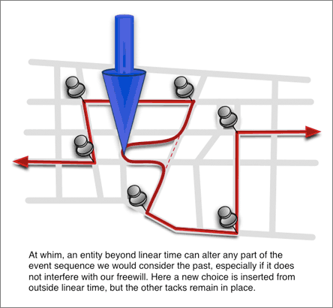
Except for feelings of deja vu, we would not naturally notice a timeline edit since our memories would change as well. We can trace the string back and find it winds a continuous path, meaning all consequences of the timeline change are consistently accounted for by preceding causes when examined. As a result, we normally remember only the most recent edit as being the past that always was.
So from our perspective time is constant, singular, and permanent. From a higher perspective, time is variable in its rate of flow and selective in its configuration. Our perception of time, like the flow of time within a movie or novel, is an illusion. The string exists from beginning to end, simultaneously, but its path is open to revision. True time moves forward not with the tick of a clock but the making of a choice. That which is inevitable has already happened.
The seemingly irreversible flow of linear time has its origins in quantum phenomena. Like a movie projector displaying successive frames to create the illusion of motion, so does consciousness continuously select from a stationary spectrum of realities which frame to experience next. The nondeterministic (unpredictable) nature of choice is what creates this one-way flow of time; at our level of existence, the collapse of a wave function cannot be reversed, and it is this collapse which generates time as we know it.
Quantum Physics of Time Travel
Last year (2005) an interesting paper appeared that investigated the paradoxes of time travel in context of quantum physics. Usually time travel is approached from the Relativity angle, involving black holes or faster than light travel, whose requirements for application are too immense to be practical. Fortunately, it turns out that the quantum interpretation opens the door to understanding some basic fourth density (beyond linear time) principles. What follows is a summary and discussion of the paper by Daniel Greenberger and Karl Svozil titled Quantum Theory Looks at Time Travel.
From the abstract:
We introduce a quantum mechanical model of time travel which includes two figurative beam splitters in order to induce feedback to earlier times. This leads to a unique solution to the paradox where one could kill one’s grandfather in that once the future has unfolded, it cannot change the past, and so the past becomes deterministic. On the other hand, looking forwards towards the future is completely probabilistic. This resolves the classical paradox in a philosophically satisfying manner.
From the conclusion:
According to our model, if you travel into the past quantum mechanically, you would only see those alternatives consistent with the world you left behind you. In other words, while you are aware of the past, you cannot change it. No matter how unlikely the events are that could have led to your present circumstances, once they have actually occurred, they cannot be changed. Your trip would set up resonances that are consistent with the future that has already unfolded.
This also has enormous consequences on the paradoxes of free will. It shows that it is perfectly logical to assume that one has many choices and that one is free to take any one of them. Until a choice is taken, the future is not determined. However, once a choice is taken, and it leads to a particular future, it was inevitable. It could not have been otherwise. The boundary conditions that the future events happen as they already have, guarantees that they must have been prepared for in the past. So, looking backwards, the world is deterministic. However, looking forwards, the future is probabilistic. This completely explains the classical paradox. In fact, it serves as a kind of indirect evidence that such feedback must actually take place in nature, in the sense that without it, a paradox exists, while with it, the paradox is resolved. (Of course, there is an equally likely explanation, namely that going backward in time is impossible. This also solves the paradox by avoiding it.)
The model also has consequences concerning the many-worlds interpretation of quantum theory. The world may appear to keep splitting so far as the future is concerned. However, once a measurement is made, only those histories consistent with that measurement are possible. In other words, with time travel, other alternative worlds do not exist, as once a measurement has been made confirming the world we live in, the other worlds would be impossible to reach from the original one.
To more accurately rephrase what is said above, a time traveler can only interact in a causal, physical, tangible manner with pasts that inevitably evolve into the future from which the time traveler came. Alternately, we in the present can only interact in a causal manner with time travelers from the very future we are currently vectoring towards.
The rules of time travel may not be as strict as this, however, since the paper ends by pointing to an alternate solution implying that “less ’deterministic’ and fuzzier time traveling might be possible.” Based on the mathematics alone, the paper shows that feedback loops between the present and future can and probably do exist, that their existence perfectly resolves time travel paradoxes by setting conditions on how the future can interact with its past. But what exactly is “less deterministic” and “fuzzier” time travel? Well, that question leads to the rest of this article.
A deterministic process is one where a perfectly predictable chain of events follows some initial known cause. A nondeterministic event cannot be predicted at all, merely described in terms of probabilities. Clearly, freewill is absent in determinism and fully present in nondeterminism. That a time traveler interacts deterministically with people in the past implies he can violate their freewill by being the cause that evokes a definite effect upon them. But then he can only do what he ended up doing anyway.
A fuzzier form of time travel is where a greater range of pasts may be accessed at the expense of decreased determinism in the interaction. In other words, the time traveler will have greater freedom to visit alternate pasts if he is more respectful of freewill. This is not his choice, rather it is a restriction enforced by the laws of quantum mechanics. The more inconsistent a past with his timeline, the less “presence” the time traveler will have while visiting.
By “presence” I mean two things: physical presence and probabilistic presence. Either will enforce the preservation of freewill. To lose physical presence means to become more ethereal. To lose probabilistic presence means you will simply not be at the right place at the right time doing the right thing to have any effect.
A time traveler can therefore visit any past at all if he remains entirely invisible and nonphysical. This would be equivalent to remote viewing the past. The more tangible he desires to be, the more restricted the range of pasts he can visit. If he wants to be fully physical, he can only enter the pasts that created his present. This is not speculation, this follows directly from the mathematics shown in the paper by Greenberger.
Fuzzy Time Travel
Of greatest interest is the “gray” zone between deterministic and nondeterministic interaction. Such “hybrid” interactions are somewhat tangible but still respectful of freewill, mostly ethereal but periodically physical, mostly subjective and only fleetingly objective. Whatever does not outright violate freewill is allowed. Examples abound: telepathic interaction, synchronistic signs and number sightings, contact through the subjective screen of dreams, abductions made dubious through memory wiping or screen memories, visitation in the etheric state, chance meetings without proof of record, an inner voice quiet enough to be ignored, a compulsion that biases but does not force, an experience meant only for a few, etc…
Fuzzy time travel happens…all the time. Technically, it is not time travel so much as one realm interacting with another in regulated ways. But being that we still exist in the illusion of linear time, much can be gleaned from thinking in terms of past, present, future, and the feedback loops between these.
It follows that the more you vector towards a particular probable future, the more tangible and objective your interaction with that future becomes. Perhaps your upcoming choices will change your path to a different set of probable futures, but for now whatever direction you are moving towards will garner you feedback from that future. This has some interesting implications.
Imagine for a moment that you are a time traveler interacting very loosely with someone of the past. You would like to interact more objectively, but quantum laws preserving freewill prohibit you. How, then, can you achieve this without violating freewill? By using your limited range of interaction to solicit or entrain the person into volitionally vectoring ever closer towards your own timeline. The more this person’s probable futures become your probable pasts, the more both of you become part of the same time stream, and the more objectively you may interact.
Negative Hyperdimensional Entrainment
This technique of entrainment to achieve greater deterministic influence is a favorite tactic of self-serving hyperdimensional entities who find it profitable to enslave other souls. The more tangibly they can do so, the less freewill their targets have to resist. From our linear time perspective, these entities come from a very negative probable future and are interacting with us now in dodgy but manipulative ways to entrain us into reinforcing their timeline, either by becoming them, serving them, or not being an obstacle to them. We know these entities more commonly as the negative variety of gray, reptilian, mantis, and nordic alien factions. Not surprisingly, their method of operation is entirely consistent with the quantum mechanics of time travel. By manipulating rather than forcing their targets toward spiritual slavery, they may ensnare souls on timelines more lush than their own.
A fascinating but disturbing phenomenon happens to people who get too paranoid, depressed, desperate, or fearful regarding matters of darkness. Alien abductees, conspiracy researchers, paranormal investigators, newbies to Matrix research – they are all vulnerable to enhancing the object of their fears by getting too emotionally entangled. Fear vectors one toward a probable future of vulnerability, initiating a feedback loop that ensures one becomes vulnerable unless the vector switches orientation towards something more emotionally and spiritually balanced.
Those obsessively fearful of grays will draw them in, those obsessively paranoid of government monitoring will receive it, those easily freaked out by the artificially synchronistic nature of the matrix will be swarmed by weirdness. The feedback loop induces a self-reinforcing downward spiral whereby traumatic experience creates fear and fear creates further trauma. The person is always free to choose transcendence and break out of the loop.
While negative emotional states lock one onto negative futures, lack of resistance or enthusiastic support out of naivete does the same. For instance, another way to increase the objective manifestation of negative aliens in your life is by happily supporting them, calling for them, beckoning to interact with them. While fear is completely lacking, you still reinforce their timeline and thereby increase how much force they can use against you. The interaction may even be of a “warm and fuzzy” nature but if out of ignorance you help what ends up being a hostile agenda, the timeloop grows in strength. Beyond a certain point it becomes very difficult to break out, especially since the increased objectivity of interaction affords them more thorough avenues for abduction, programming, implantation, and control. This undermines your ability to resist. So these dark forces work either by entraining you emotionally into vectoring towards them or deceiving/suppressing you intellectually into supporting them.
Positive Hyperdimensional Entrainment
Enough on darkness. Let’s discuss how to apply the quantum mechanics of time travel towards positive ends. The first and most obvious application is strengthening one’s connection with positive forces, namely the Higher Self. The second application is in forcing reality to correct perturbations to well-established feedback loops via miracles, as shall be explained shortly.
What is the Higher Self? Simply the final version of you that has become fully manifest in potential. Should your conscious evolution continue indefinitely, it is inevitable that sooner or later you would reach the heights of individual spiritual perfection, a state in which your wisdom and power has grown profound and your mind has fully transcended the limits of time and space. While that is yet to occur, its inevitability means it has already happened. If your future self transcends time, then its consciousness may naturally extend “backwards” and overlap the consciousness of all its past incarnations simultaneously.
In other words, although from your linear perspective the Higher Self is a distant probable future, ultimately this future perfected self exists right now alongside you. According to the quantum principle discussed in this article, the more you vector towards becoming the Higher Self, the more objectively the Higher Self can interact with you. A weak connection means its guidance is limited to faint intuitive impressions, symbolic dreams, certain synchronicities, and so on. A stronger connection would allow direct inner conversation, which is clearly more objective than vague impressions. The voice of the Higher Self is often described as a “small, still voice” meaning an inner knowing that is easily drowned out by mental distractions. A prolonged and sincere effort to think, feel, and act like the Higher Self — to live from the highest part of you, the heart of your soul — increases the feedback loop and widens your capacity to act as a channel for your future self. You are then merging with who you truly are. The prodigal son returns home.
Whatever you want to connect with, simply support it, reinforce it, try to become it. People who pray to Jesus from the standpoint of weak beggars receive no response because they are vectoring towards a future of disempowerment and victimhood, a direction opposite to what the Christ represents, and so they receive little feedback. Those who call upon the divine impulse within, recognize it, and do their best to express it receive reinforcement.
Manifesting Miracles
Another application of quantum time travel laws pertains to the creation of miracles. A miracle is a highly improbable but meaningful event that serves a recognizably positive purpose. Some miracles are intentionally inserted into the timeline as a matter of divine intervention, but they also happen as a consequence of natural law. “Leap and the net will appear” is proven through experience, but its explanation is most elegantly handled by timeline dynamics as follows:
There exists a bundle of probable pathways between the present moment and some particular future. The straightest path is the most probable and mundane, while the more deviating paths are less probable. The greater the deviation, the more fantastic or bizarre the correction necessary to ensure that future. So if you can stay locked onto a particular future, any excursions you take that might upset its fulfillment merely brings you onto a less probable path towards that same future, a path whose initial excursion is redressed by a miraculous correction.
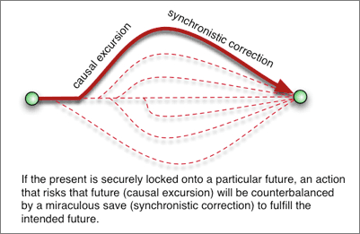
How to lock upon a particular future? By resonating with it. Your soul vibrational spectrum, which is somewhat equivalent to your emotional temperament or learning style, determines what range of probable futures you resonate with most and therefore attract. The more hostile, reactive, depressive, fearful, fanciful, passive, or jaded your regular mode of being, the harsher and more painful the types of experiences attracted. The more confident, attentive, serene, exultant, warmhearted, and patient you are, the more your experiences will reinforce those qualities by being of a positive nature.
You enter into temporal feedback with futures that spawn from your current mode of being, a self-reinforcing process that keeps you within the bundle of probable paths consistent with a resonant range of futures. Once this feedback loop is established, you can then take risks that merely send you on a more exciting trajectory towards the same successful future. In other words, if through a positive state of mind you connect with a positive future, then by maintaining that inner connection your experiences will adjust accordingly to ensure everything works out.
The trick is in making your causal excursion as nonchalantly as possible. Worry reorients your vector towards a disappointing future. Anticipation constricts the quantum fluidity of a probable future and prevents it from manifesting synchronistically. Remaining dispassionate when taking a risk ensures that you maintain your original vector and stay within the intended bundle of probable paths. It is much like telling a scriptwriter that no matter what scene opens an act, the act must have a happy ending; then the more perilous the opening scene, the more amazingly the plot must transition to manifest a happy ending. If a month from now you will be financially fine, then spending on something that assists your growth — and thereby reinforces a positive future — guarantees that some miracle must manifest to reimburse the purchase.
Summary
In a nutshell, according to quantum physics we are caught in mutual feedback loops with all our probable futures. The greater the probability of a particular future, the stronger the feedback loop, the more tangibly beings from that future can interact with you in the present. By choosing to become more positive and aware, you establish mutual reinforcement with positive futures and thereby increase the number of miracles necessary to evolve you into those futures. The enormous implications I will leave to your imagination and experimentation.

